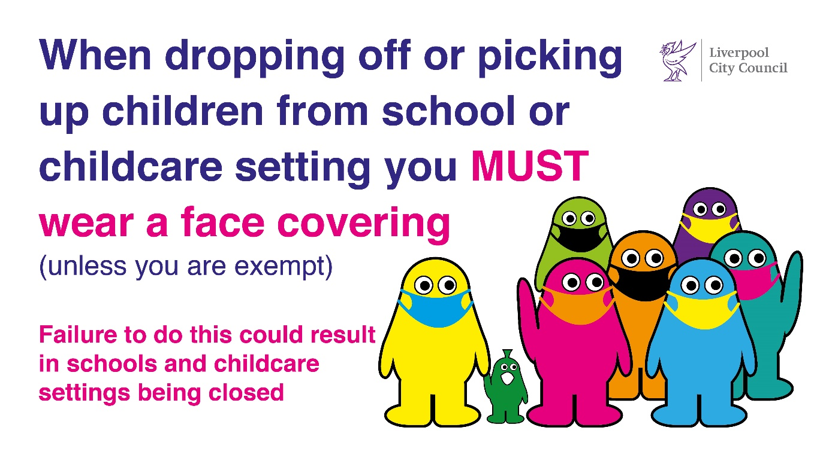
Our ref: JPC/MK
Be Covid Safe
Wear a face covering
Your ref:

14 April 2021

Dear Parents & Carers

On Monday 19th April we will be starting another of our lovely attendance incentive schemes.

This will be for four weeks (20 school days but we have one bank holiday and Thursday 6th May when school is closed for elections) so 18 attendance days in total.

All children who have 100% attendance and PUNCTUALITY (8:45 – 8:55) will be rewarded with a fun activity on Friday 14th May and will be entered into a prize draw with a £20 Tesco voucher for the first name out of the hat!

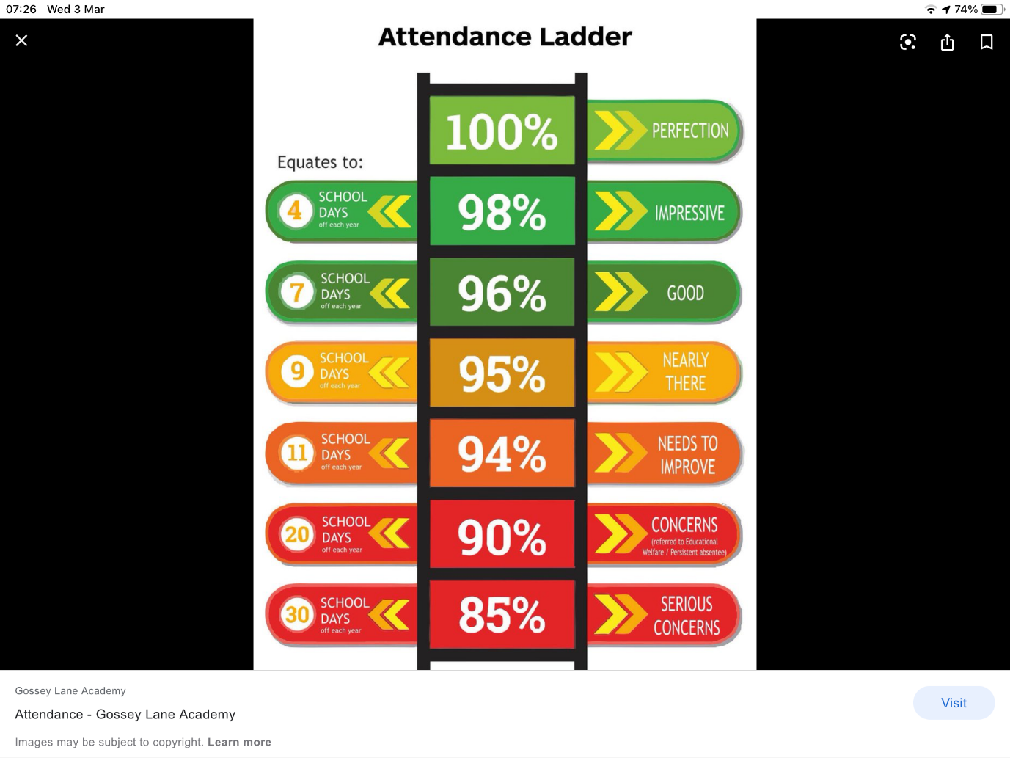
Covid has been tough for us all and we will need to make every minute of learning count.

Remember our whole-school target is 97%.


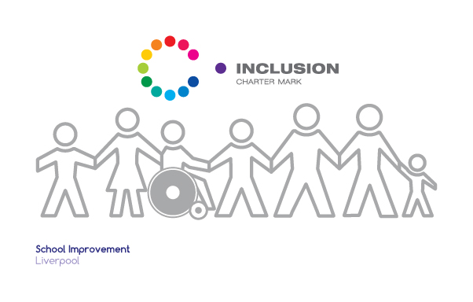
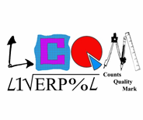

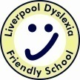



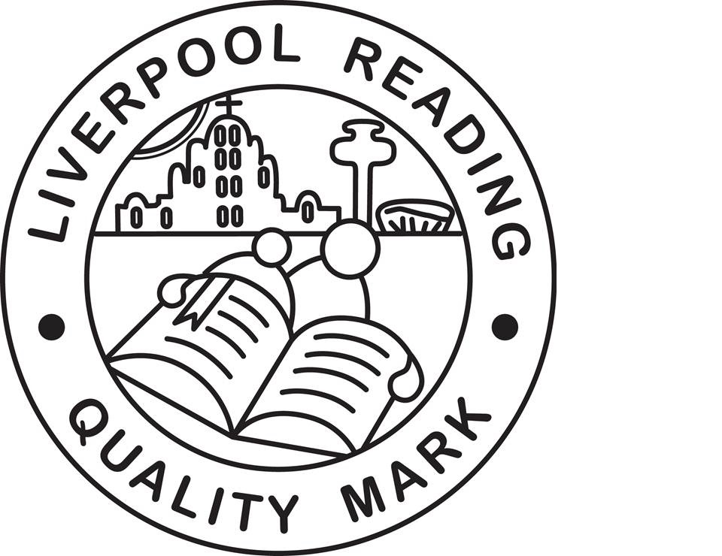







Mrs Conley & Mrs Harkness

